Jay Kalyanbhai Savani

CWID – 20009207

Assignment – 5.1

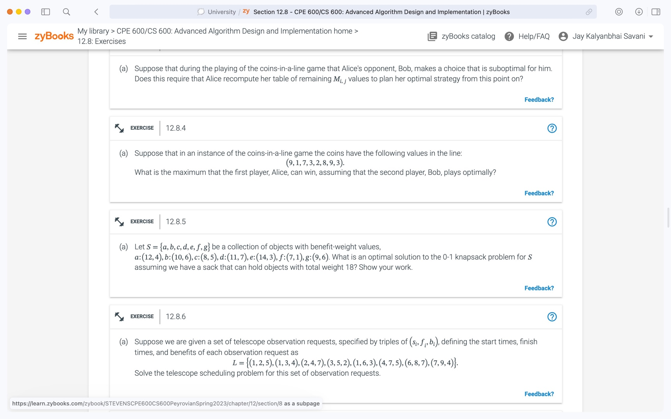

ANS: Total Weight object can hold is 18.

Here,

a: (12, 4)

b: (10, 6)

c: (8, 5)

d: (11, 7)

e: (14, 3)

f: (7, 1)

g: (9, 6)

|  |  |  |  |  |  |  |  |  |  |  |  |  |  |  |  |  |  |  |  |  |
| --- | --- | --- | --- | --- | --- | --- | --- | --- | --- | --- | --- | --- | --- | --- | --- | --- | --- | --- | --- | --- |
|  |  | 0 | 1 | 2 | 3 | 4 | 5 | 6 | 7 | 8 | 9 | 10 | 11 | 12 | 13 | 14 | 15 | 16 | 17 | 18 |
| B, W | 0 | 0 | 0 | 0 | 0 | 0 | 0 | 0 | 0 | 0 | 0 | 0 | 0 | 0 | 0 | 0 | 0 | 0 | 0 | 0 |
| 12, 4 | 1 | 0 | 0 | 0 | 0 | 12 | 12 | 12 | 12 | 12 | 12 | 12 | 12 | 12 | 12 | 12 | 12 | 12 | 12 | 12 |
| 10, 6 | 2 | 0 | 0 | 0 | 0 | 12 | 12 | 12 | 12 | 12 | 12 | 22 | 22 | 22 | 22 | 22 | 22 | 22 | 22 | 22 |
| 8, 5 | 3 | 0 | 0 | 0 | 0 | 12 | 12 | 12 | 12 | 12 | 20 | 22 | 22 | 22 | 22 | 22 | 30 | 30 | 30 | 30 |
| 11, 7 | 4 | 0 | 0 | 0 | 0 | 12 | 12 | 12 | 12 | 12 | 20 | 22 | 23 | 23 | 23 | 23 | 30 | 31 | 33 | 33 |
| 14, 3 | 5 | 0 | 0 | 0 | 14 | 14 | 14 | 14 | 26 | 26 | 26 | 26 | 26 | 34 | 36 | 37 | 37 | 37 | 37 | 44 |
| 7,1 | 6 | 0 | 0 | 0 | 14 | 14 | 14 | 14 | 26 | 26 | 26 | 26 | 26 | 34 | 36 | 37 | 37 | 37 | 37 | 44 |
| 9,6 | 7 | 0 | 0 | 0 | 14 | 14 | 14 | 14 | 26 | 26 | 26 | 26 | 26 | 34 | 36 | 37 | 37 | 37 | 37 | 44 |

As we fill up the values as per the formula:



We see that the maximum benefit is 44.

We will get the optimal solution from {(12,4), (10,6), (8,5), (14,3)}

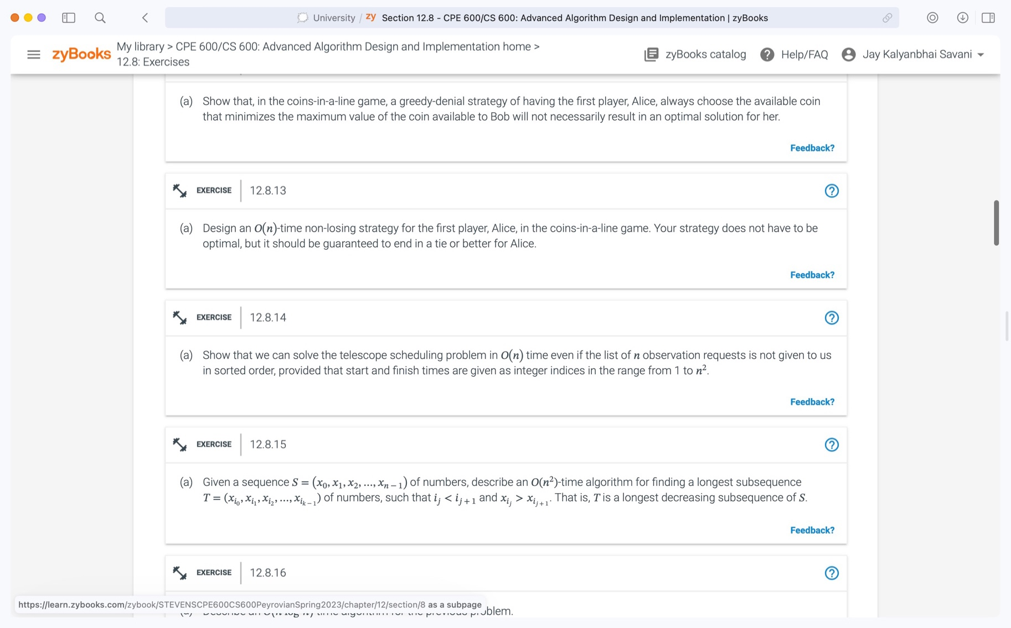

ANS: Algorithm for telescope scheduling:

Ordering of requests by finish times and an array, P, so that P[i] = pred(i), then we can fill in the array, B

B[0] ← 0  
for i = 1 to n do

B[i] ← max{B[i − 1], B[P [i]] + bi} A

It will take O(n log n) time to sort the list of n observations since it is not sorted, and O(n) time for the for loop in the method. As a result, this method will execute in O(n log n + n) total time.

We investigate the value O(n) omitting log n for high values of n. It is simple to sort n observations in O(n) time. Hence, the complete array B can be computed in O(n) time.

We use dynamic programming to identify the best solution for inputs 1 to n2. Nevertheless, the brute force technique will perform better if the size changes by 2n.

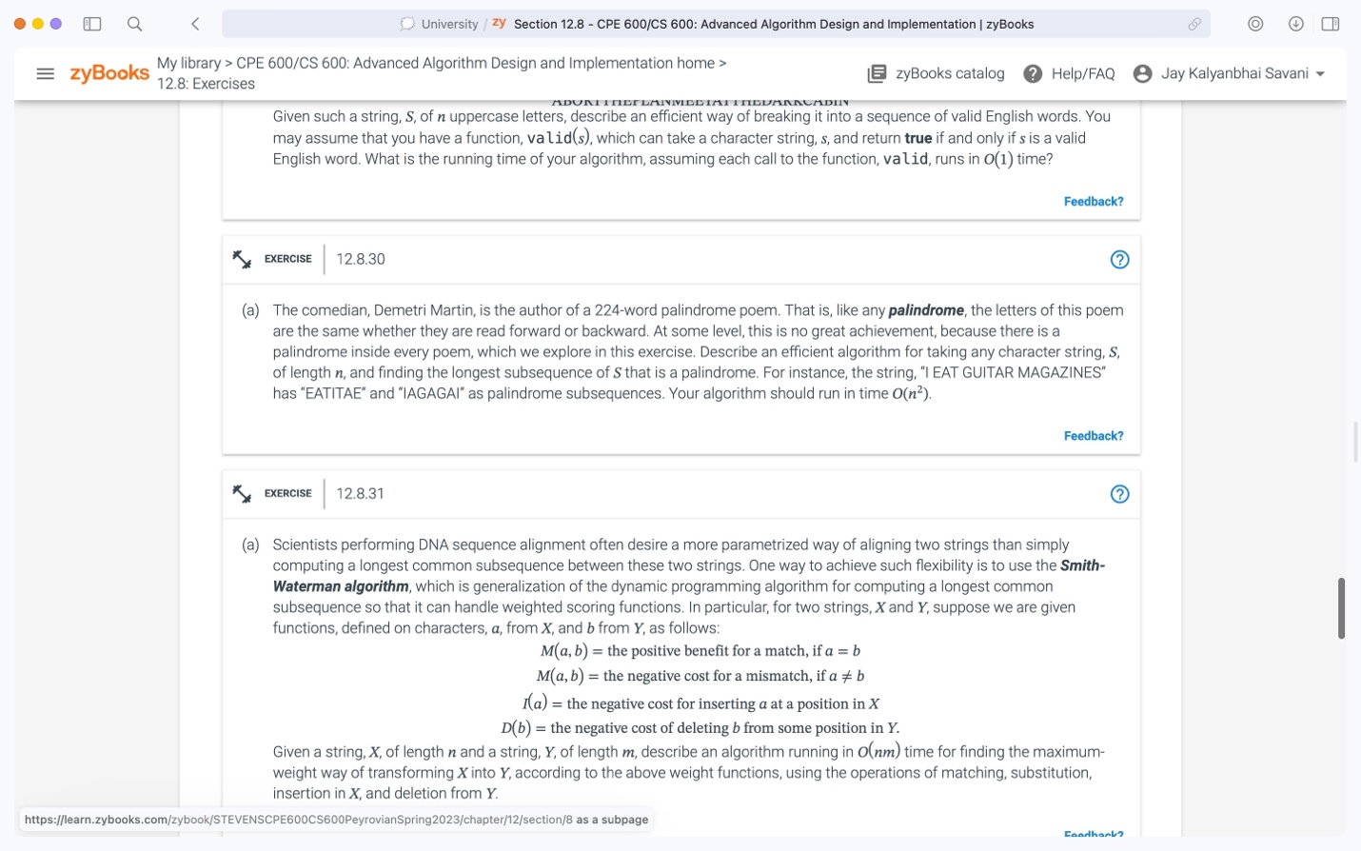

ANS: Algorithm to find the longest subsequence of S that is a palindrome:

Input: Palindrome of string S of length [0 … n-1].

Output: The length L[i, j] of longest common sequence of a palindrome S[0 … n-1]

**for** i ← 1 to n **do**

L[i, i] ← 1

**for** i ← 2 to n **do**

L[i, i-1] ← 0

**for** i ← n-1 to 2 **do**

**for** j ← i + 1 to n **do**

**if** L[i] = L[j] **then**

L[i, j] = L [i+1, j-1] + 2

**else**

L[i, j] = max {L[i+1, j], L [i, j-1]}

**return** array L

Now, we verify the sequence's first and final characters first. As a result, we will know if two characters are the same or not.

If both characters match, we subtract both and add 2 to the result before adding the result to the array L.

If the two characters vary, we calculate the remaining subsequence while taking into account the first character to solve the issue. After that, we fix it by going back to the first step and selecting the last character.

The highest of the two outcomes will be recorded.

The method employs two for loops, one inner and one outer, both iterating n times. Within the loop, there is an assignment and an if statement that take up O(1) time.

Hence, the algorithm's overall running time is O(n2).